Sediment | Flow time (s) | Water recovered (mL) | Permeability (mL/s)
Sand | 54.8 s | 19 mL | 0.347 mL/s
Gravel | 5.4 s | 44 mL | 8.148 mL/s
Gravel & Sand | 88.7 s | 30 mL | 0.338 mL/s

pH: 7

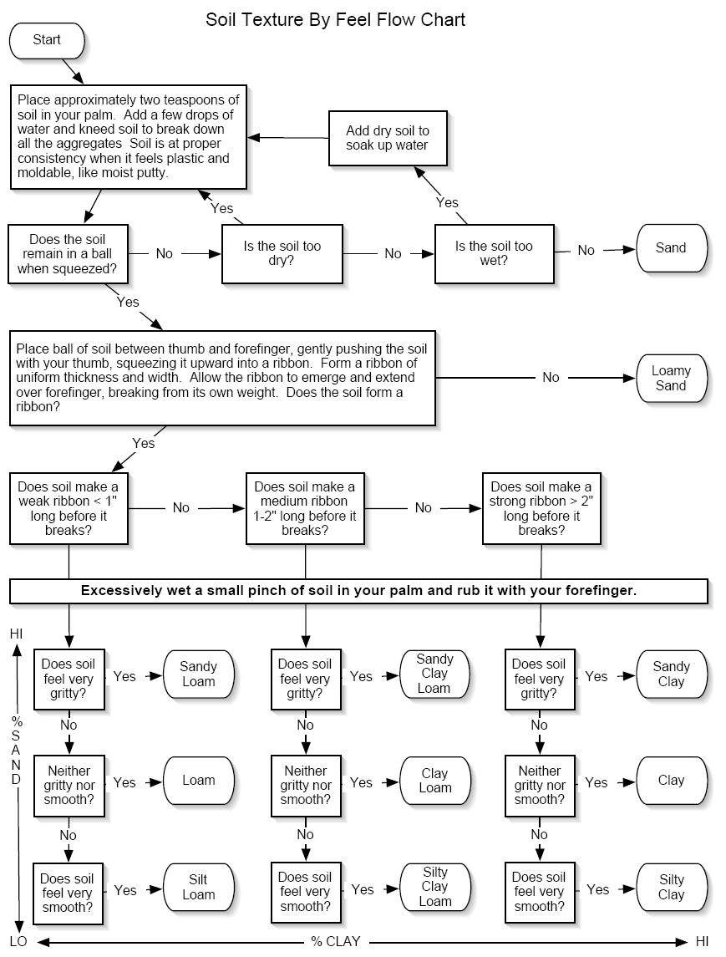

Soil Make-Up: 83% sand, 13% silt, 4% clay

