Light (Day)
Time | Container 1 | Container 2
0:00 | 65˚F | 62˚F
2:00 | 66˚F | 64˚F
4:00 | 66˚F | 64˚F
6:00 | 67˚F | 65˚F
8:00 | 67˚F | 65˚F
10:00 | 67˚F | 65˚F
 |  | 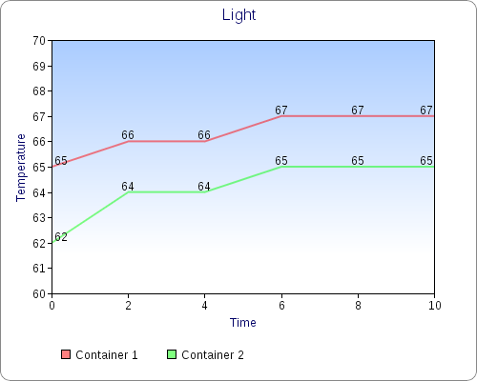
No Light (Day)
Time | Container 1 | Container 2
0:00 | 65˚F | 64˚F
2:00 | 61˚F | 63˚F
4:00 | 61˚F | 63˚F
6:00 | 61˚F | 63˚F
8:00 | 61˚F | 63˚F
10:00 | 61˚F | 63˚F
