Data & Calculations

ORIGINAL NUMBER TAGGED _______10________________
Sample # | # of tagged fish in sample | Total sample size | % tagged
1 | 4 | 55 | 7.3%
2 | 1 | 22 | 4.5%
3 | 0 | 14 | 0%
4 | 2 | 47 | 4%
5 | 0 | 13 | 0%
6 | 1 | 35 | 2.8%
7 | 1 | 20 | 5%
8 | 3 | 27 | 11.1%
9 | 0 | 19 | 0%
10 | 0 | 22 | 0%
11 | 1 | 22 | 4.5%
12 | 0 | 25 | 0%
13 | 2 | 29 | 6.8%
14 | 2 | 26 | 7.6%
15 | 1 | 23 | 4.3%
16 | 0 | 8 | 0%
17 | 1 | 30 | 3.3%
18 | 0 | 13 | 0%
19 | 0 | 35 | 0%
20 | 2 | 16 | 12.5%

Average Percent Tagged _____3.685%_______________

estimated population size: number tagged / mean of the sample percentages = _____271.37________________

Actual population size = ________221_____________

% error between actual population size and estimated population size = _______22.8______________

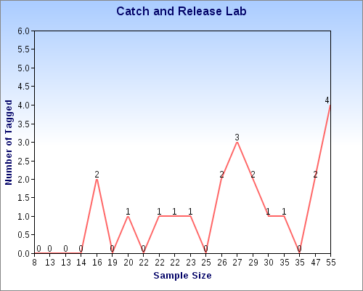

Results from other groups: Ordered by Percent of Error from Lowest to Highest
# tagged | Number of samples | % error
20 | 20 | 0.5%
30 | 15 | 2.5%
30 | 10 | 4%
10 | 20 | 7.87%
20 | 15 | 8.9%
30 | 10 | 9.5%
10 | 15 | 11%
20 | 10 | 16.2%
20 | 15 | 19%
10 | 20 | 22.8%
20 | 20 | 27.5%
10 | 10 | 31.3%
30 | 20 | 32.5%
30 | 15 | 124%

